AFTERTHOUGHT VIDEOS

In looking for Poly-related videos and photos for the Alumni Office, I ended up finding what I wanted along with a bunch of other stuff (see my cat directly below). I began including everything in the Afterthoughts document (a Word document) but soon realized I was running into a storage problem. Additionally, because I was going to have to turn everything into a pdf where active URL’s are lost, I created this document along with the YouTube URLs that go with the videos. Hope you get a kick out this stuff.

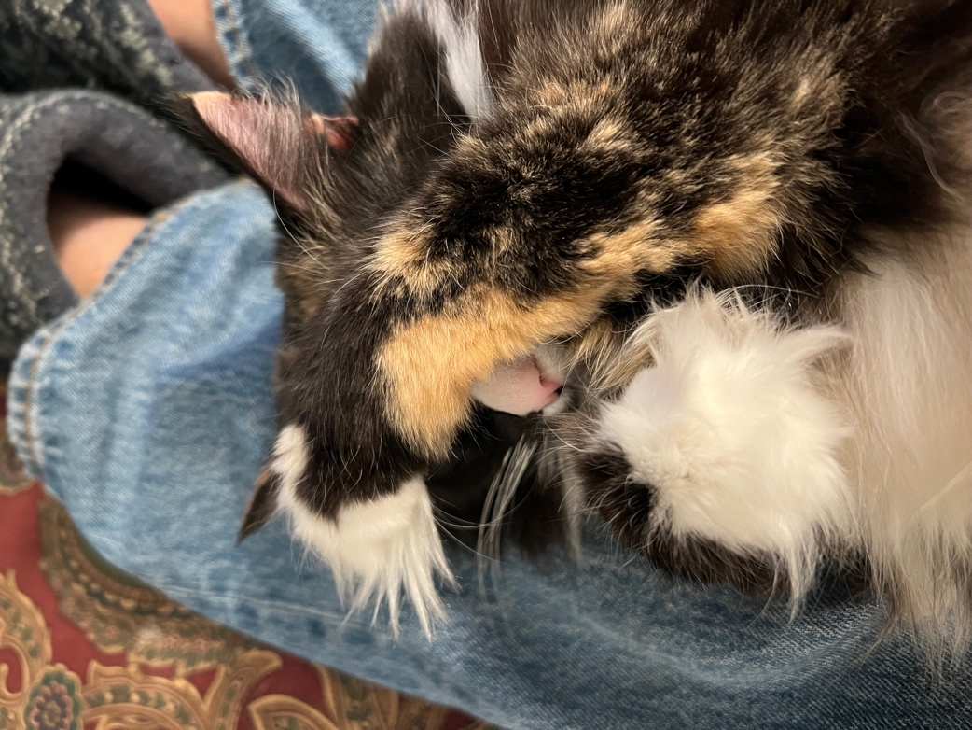
The first photo is of my cat, Isabella, who is lying on my lap (you can see the top part of the booties I’m wearing at the top of the photo). It isn’t obvious unless you look at it closely, but she is lying on her back with one paw over her eyes (the easiest way to see it is to find an ear at the top, then find the nose in the middle.

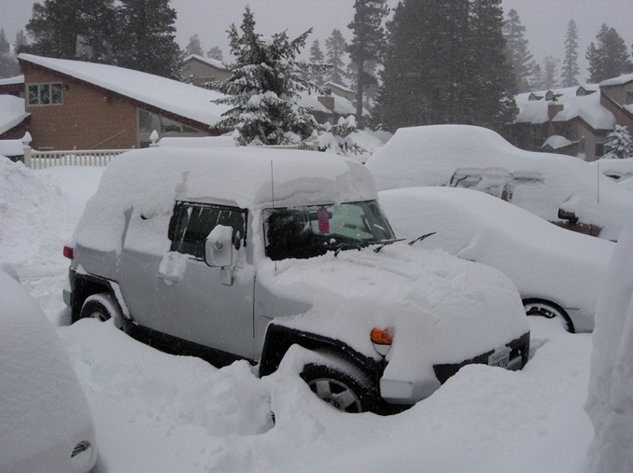
Patty and I (and possibly Brad, her husband) went skiing in Mammoth over a long weekend one year. On the last night we got a snow dump. Fortunately, the vehicle had four-wheel drive, so we were able to get home even though the roads were iced over.

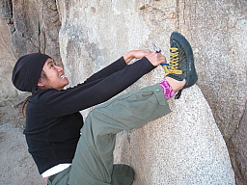
This is a rock-climbing/bouldering shot of Patty during a trip she and I and Richard and a bunch others took to a place called Red Rock Canyon outside Las Vegas. What makes this photo so amusing is that she looks as though she is making a big rock-climbing move, when in fact her butt is about a half foot off the ground. It was definitely a slight-of-hand shot.

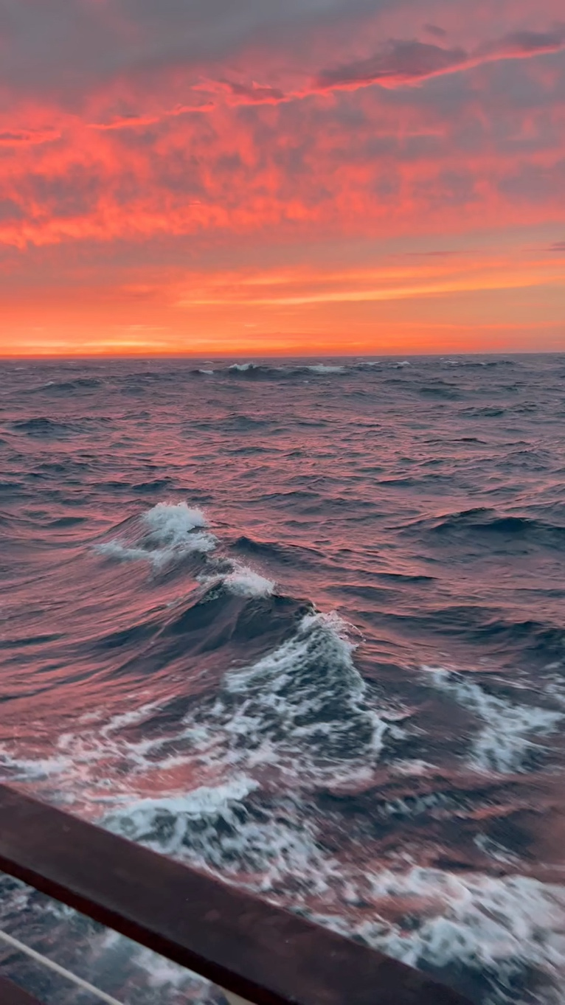

The sunset photo is actually a video. If you double-click on it, it may come to life. The video was taken during the Tall Ship class trip I did in September of 2025. Because I wasn’t sure if this video would run here, I put it on YouTube. Its URL is https://youtube.com/shorts/z3Mh2hdNITY? .

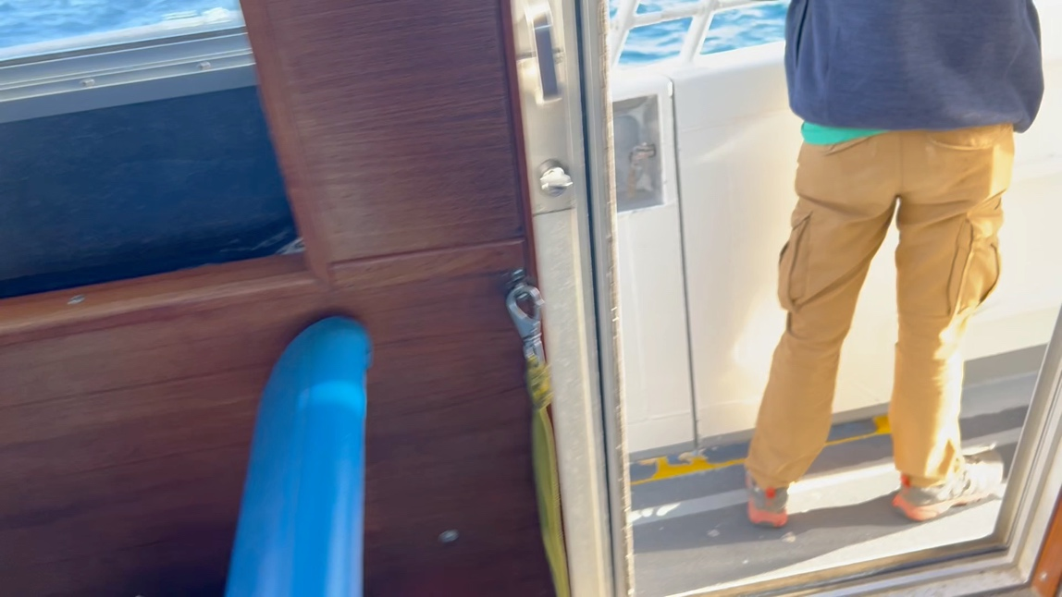
I’ve been on several trips to areas in the Channel Islands off the coast of Southern California. On the trips when we’ve taken a water taxi, it has not been uncommon to find ourselves moving along with a large group of leaping and frolicking dolphins. The video above was an attempt one year to capture all the fun (the action really picks up about two-thirds of the way through the video). I made a YouTube of this also. It can be found at https://youtu.be/3sEOnZHWAEU .

This was hilarious. For years and years, the junior class trip saw the entire junior class paddle 70 miles down the Green River in Utah in canoes en masse. The trip was quite cool. The paddling was lazy (the river section we did was not whitewater) and the mud in the mud flats along the way had the consistency of Coal Cream (this was a smooth, topical cream women used to put on after taking off their make-up at night—it is very slippery) so the mud fights along the way were epic. The point is, though, that the trip saw anywhere from 70 to 80 seventeen-year-olds (plus guides and chaperones) canoeing the river (two per canoe) in a giant clump.
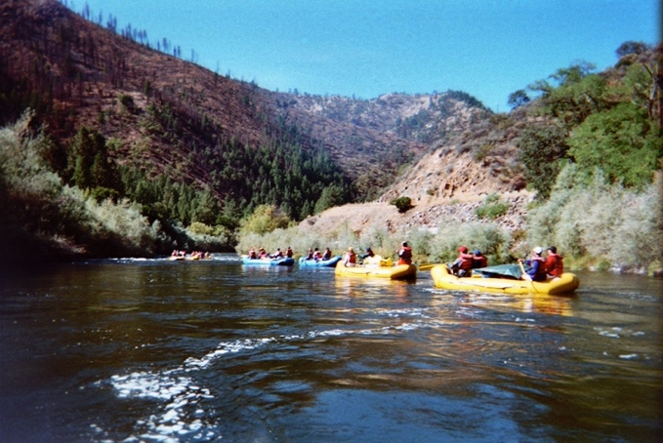
After several years of enduring the 13-hour bus trip (at night) to get there, we began to run into problems with the locals. Sierra South, the outdoor company that ran the trip for us, decided they were gouging us on canoe rentals and began bringing in their own canoes rented hundreds of mile away. The locals enlisted the Forest Service to make things hard for us, and things more or less deteriorated from there.
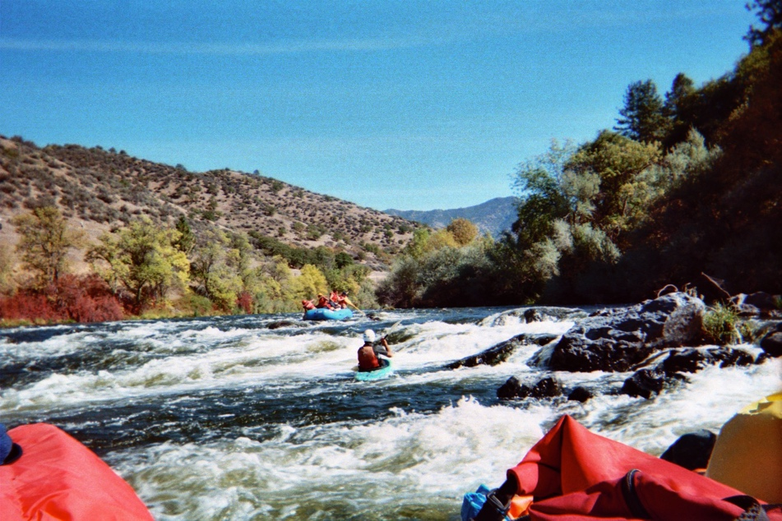
The long and short of it was that at some point, Sierra South put together a “new” trip down the Klamath River on the Oregon/Washington border. This was a whole other kettle of fish. For one, the section we did was whitewater done in rafts (five kids per raft with one kid acting as guide). This was way more fun the Green because, well, whitewater is just fun, but it was also more dangerous. We had Sierra South guides, mostly in kayaks, but still—kids guiding their own boats. Yikes!
Anyway, the first photo is of the flotilla on relatively calm water.

The second photo to the right gives you some feel for what the river looked like at river level.

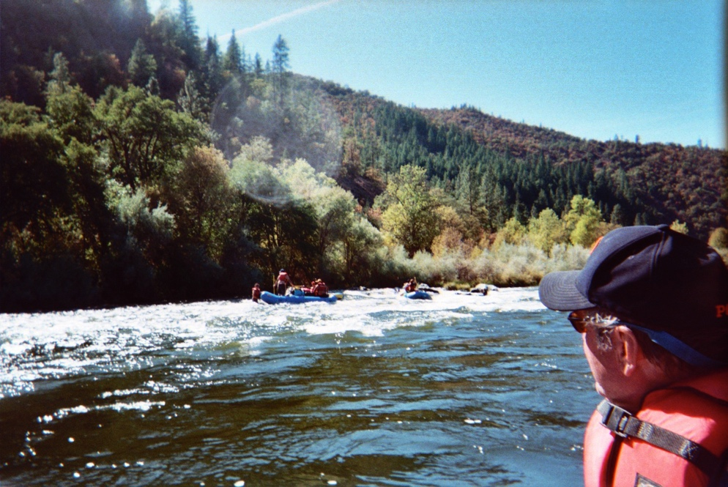
The third photo shows kids standing in the river trying to get their boat off a rock (the water level was low in some areas).

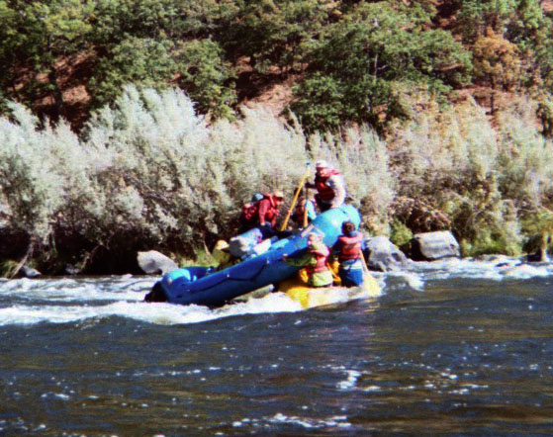
The really amusing part of this story is that at some point, a boat got hung up on a rock (just like the third photo), except a second boat with its student driver was following too closely and ended up hitting the first boat, sliding up underneath it so the two boats were stacked, one on top of the other. HILARIOUS!!! If you look at the last photo, you can see how the second boat had turned sideways lifting the first boats fanny up into the air. You can’t buy amusement like that . . .

I talked about the balloon prank in the autobiography, but I found the two photos shown below after publication. I think they are better pictures of what happened, so I’m including them here.
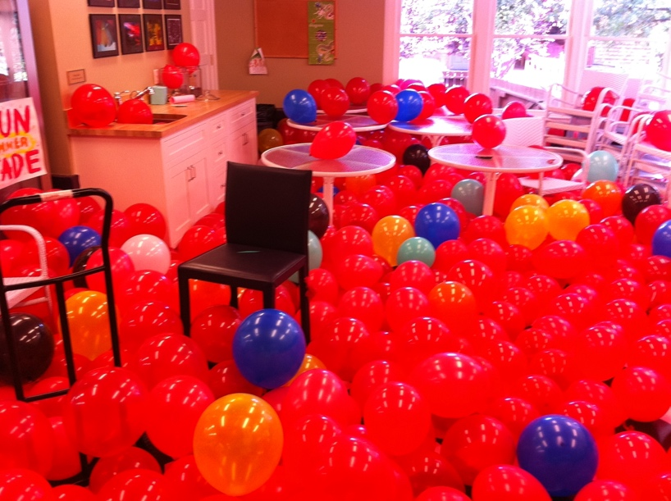
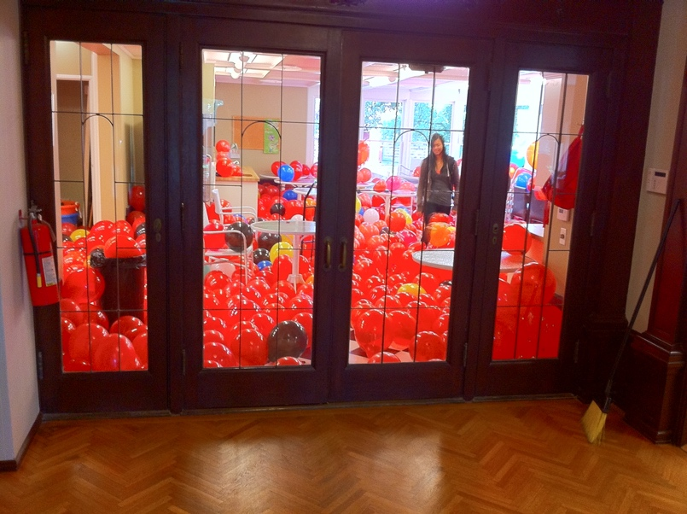

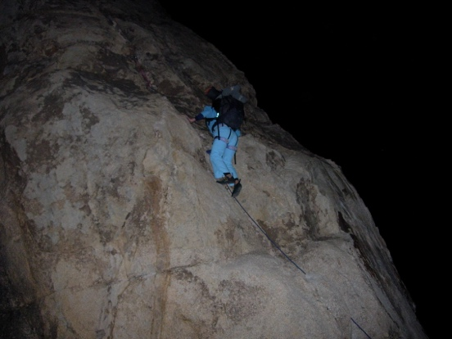
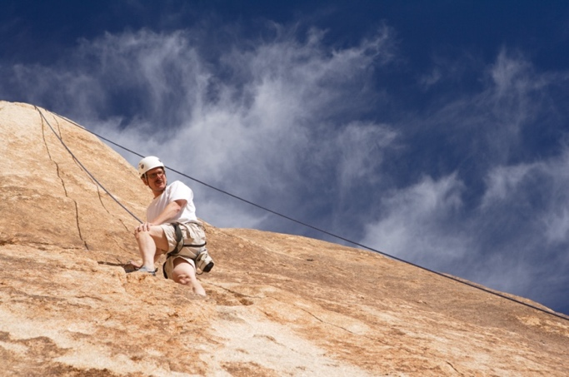
When Richard White came to Poly, he was not only a great physics teacher, he was an accomplished rock climber. During his first year, he proposed to Patty Thurlow (Patty Tsai at the time) and me a weekend rock climbing trip to Joshua Tree in early December (there were others invited, but I don’t remember who-all went). Richard was the only one who knew HOW to rock climb, but everyone on the trip was athletic and quick learners, and the trip became a yearly event for a good ten years. The first photo is of me up on a relatively benign slope. We did stuff that was considerably more challenging. In any case, there I am.
Also, one year we did a night climb. I think doing that was illegal (or, at least, very much frowned upon), but we did it anyway. The climb wasn’t difficult but was “different’ in the sense that we had to carry all our gear with us as we slept on top. The second photo is of Patty halfway up the wall.

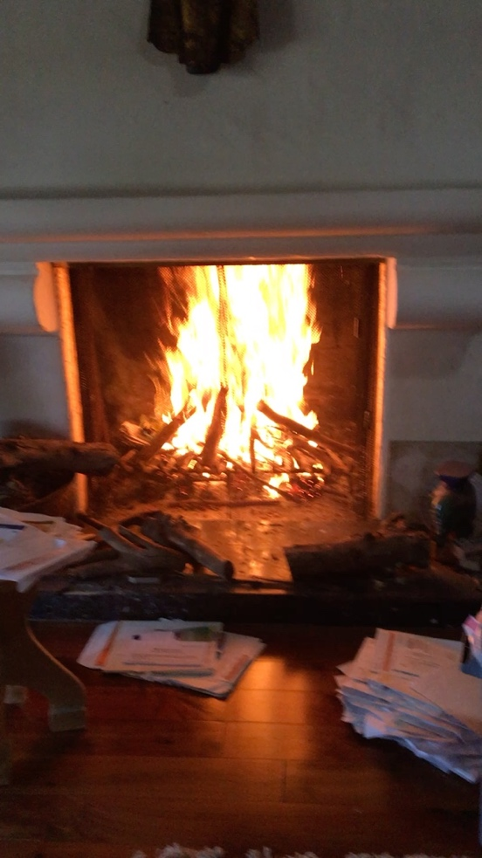
My fireplace really roars when it gets going. I don’t use it much anymore because I know that the wood I burn is releasing lots of carbon dioxide into the atmosphere, so I only do it on rare, special occasions. Nevertheless, back in the old days when we weren’t so worried about such things, I made this video of my fireplace in action. If the video doesn’t run here, you can see it on YouTube at https://youtube.com/shorts/9S-TkPl_Fws?feature=share .

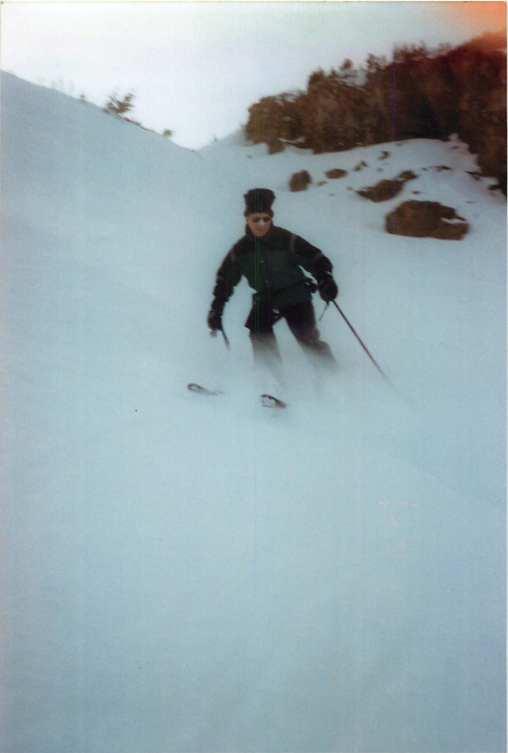
This photo has a bit of a comedic look to it. I used to ski whenever I got the chance, and when I would I’d protect my nose (having had two melanomas removed from it earlier in life) with zinc oxide. That made me look odd enough, but I also wore a rolled-up balaclava that ended up looking like a beanie hat with a mushroom top. Fashion statements were clearly not a part of my younger life.

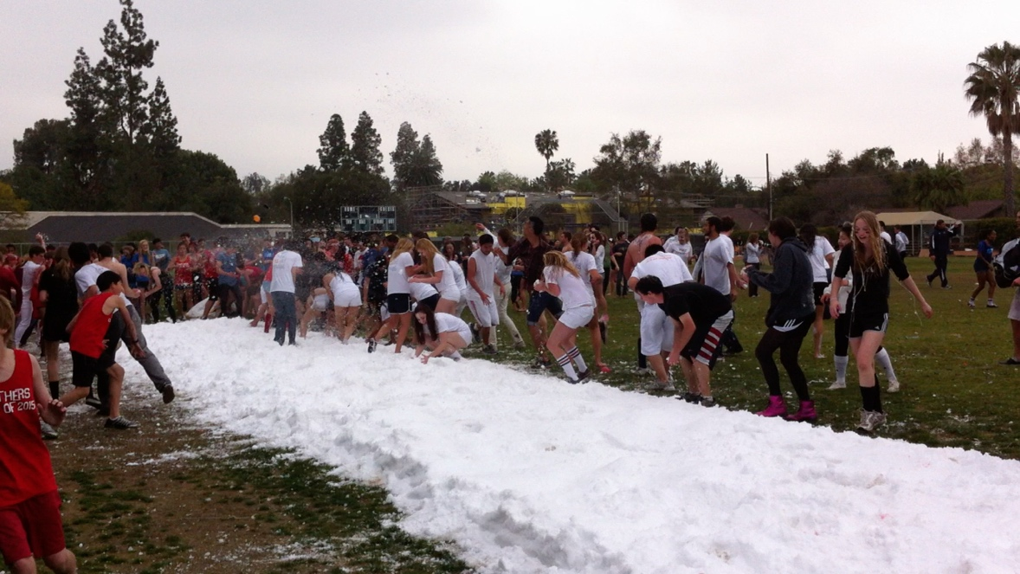
Snow is not something you find a lot in Pasadena, California, but one year someone managed to haul in a ton of snow (literally), lay it out on the field and let the students have a giant snowball fight. It was a hoot. The URL for the YouTube video is https://youtu.be/Ko46e2nS6bU .

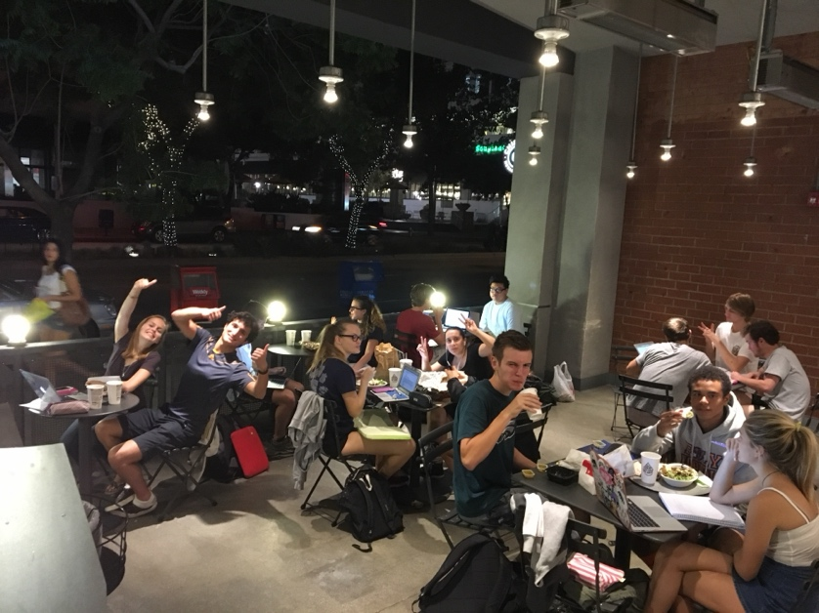
When Richard White arrived at Poly in the mid 2000’s, he brought along with several traditions that were quite fun. For instance, he (and I) would show up at an appointed hour at Chipotle’s restaurant on Lake a day or two before a test, and just hang out. It wasn’t a formal review session, but students knew they could come at the time, maybe buy dinner, then sit in the outdoor eating area and do physics problems. If there was something they couldn’t figure out, or if they had questions, there’d we be (Richard and I), ready to help out. It was a very nice thing to do for the students, and it would never have passed through my mind to offer it if it hadn’t been for Richard.

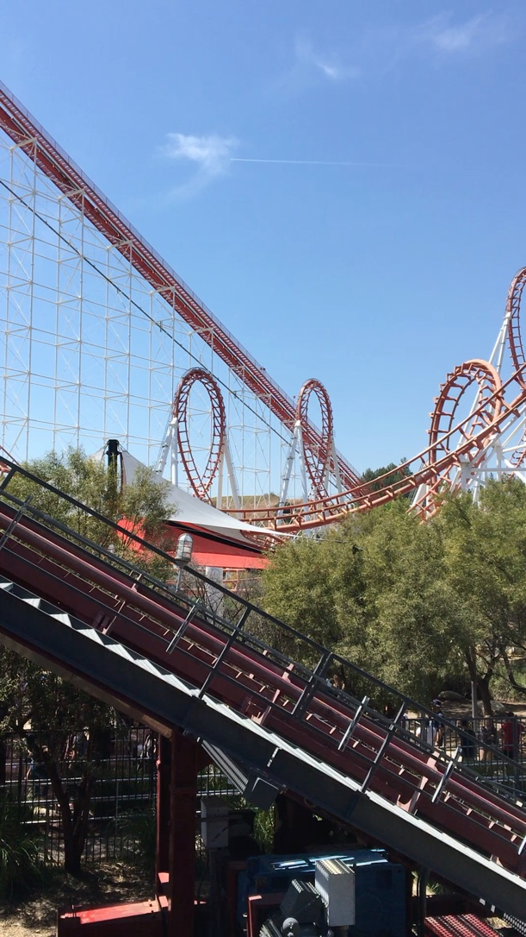
Another of Richard’s gems was having the kids take a day off from school, go to Six Flags Magic Mountain and take the data required to solve an assigned physics problem (each kid got their own problem, but the kids would work in pairs and they could decide which of their two problems they would do—the write-ups were supposed to be done independently of one another). The video to the right was probably taken to get data for the following question: What is the net forces acting on a cart as it travels through the top of the middle-loop of the so-and-so roller coaster? By looking at the video and making distance and time approximations, you could use the idea of centripetal forces (mv²/R) to determine that force. To do that, you needed the velocity and path radius. The video did the job. (The URL for the YouTube video is https://youtube.com/shorts/IYu_FYfa1C0?feature=share).

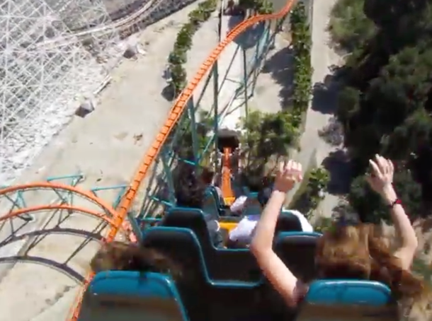
Once the students were done getting their data, they were free to frolic for the rest of the day. As the kids were pretty much on their own once they got into the park, the chaperones would also frolic. One the more fun rollercoasters (I can’t remember its name) has a huge drop right at the beginning of the ride. One year, I videotaped the ride. The URL for the YouTube video is https://youtu.be/qV-KIgs1mAE .

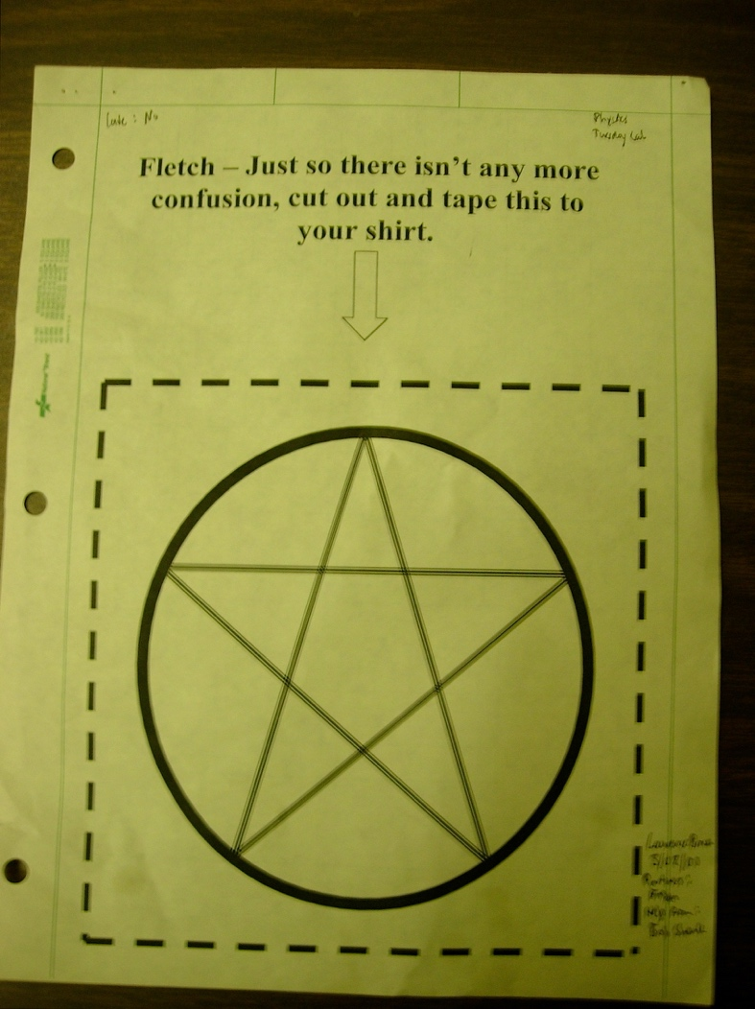
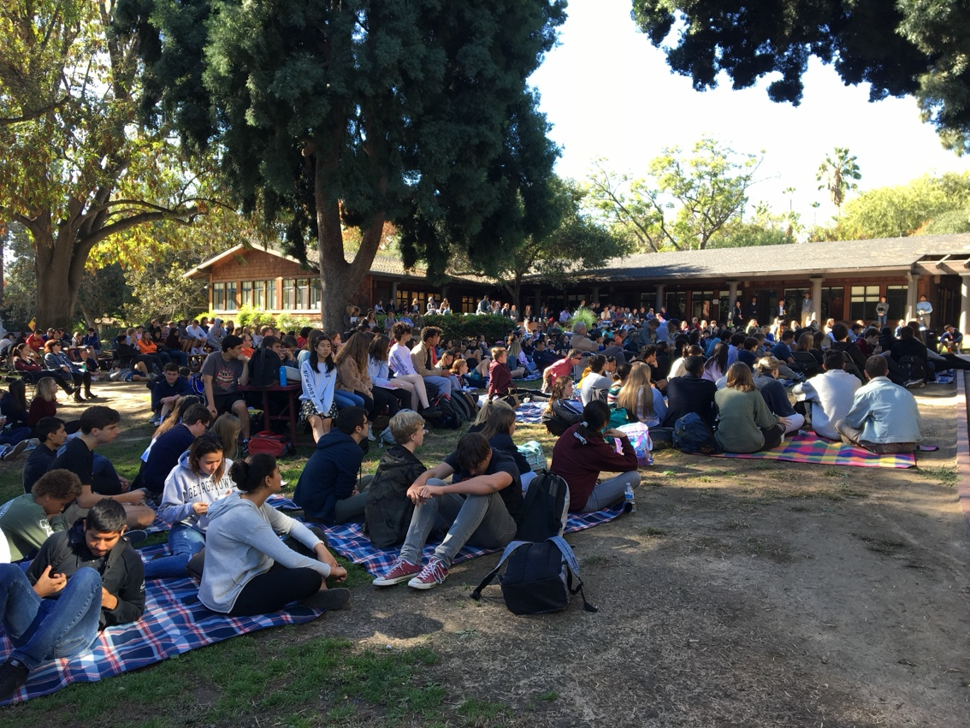
At some point during the Covid years, the school stopped having school assemblies and meetings in the auditorium and instead had them on the “front lawn” out in the open. I’m not sure if the photo was of the proceedings just before Covid or far enough after than nobody was wearing masks, but the photo shown is of that.

My students were always chivying me about something. In the lab cover to the right, someone is teasing me about my eastern metaphysical knowledge, if knowledge be the right word.

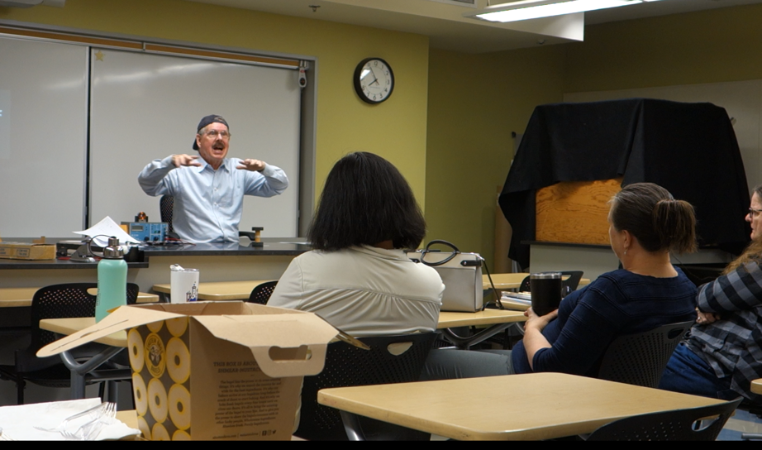
A year or so before my semi-retirement, the science department gave me forty-minutes to show off some of the really cool demonstrations I might have up my sleeve. Someone made a video (actually in two parts). If you would like to see me in action showing cool demos in the process, the first video is at https://youtu.be/ym55r8tPSOM. The second part is at https://youtu.be/JHOYog6aXx8.

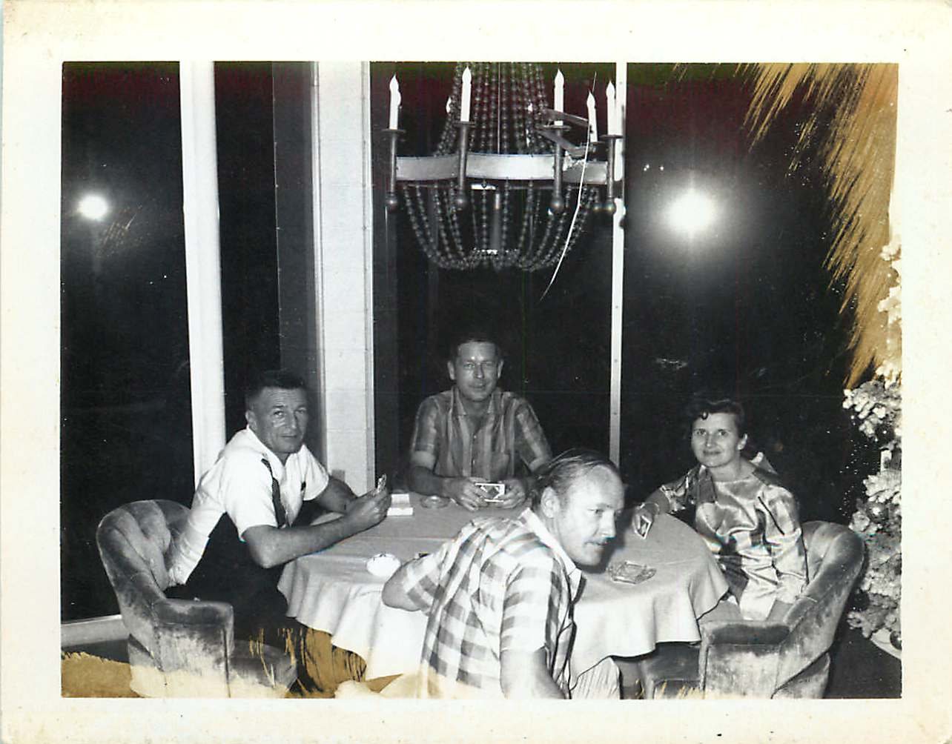

This, I guess, will be the last of the photos (unless I find a trove later). I’m including it because it has my dad in it.
My dad was a very nice guy. Sometime in the early 1960’s, he and his partner, Jack, built a magnificent house in the hills above Covina. They had enormous picture windows in living rooms that look out into the valley below, and at least once a month dad’s brother Bill and his wife, Ginger, would retreat to dad’s house or Bill and Ginger’s house and play Bridge. The photo you are seeing to the right is of the four at dad’s house doing just that (the huge windows are to his back—it was night so you aren’t treated to the splendid view). My dad is seated farthest from the camera with Jack closest. Bill and Ginger are obvious.

